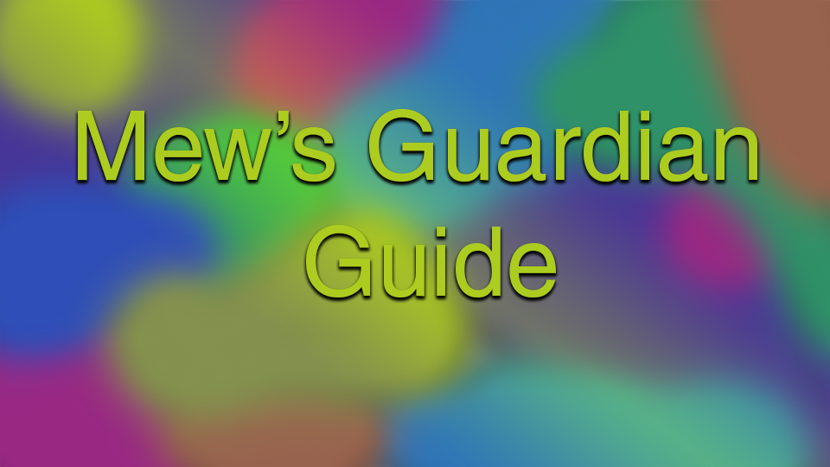

FULL, UPDATED POST: <https://mewsie.world/CoraTOWiki/index.php/Mew%27s_Guardian_Guide>

PLEASE EXCUSE THE MESS; Drive is not happy with the way I like to format things

Are you stuck on your guardian? Do you not know where to start? Do you want insider tips and tricks to speeding up the process? Do you like pictures and a comprehensible layout for your guides? Look no further! Mew’s got you covered. From a decade old player and the proud owner of currently 9 guardians on rTO and 2 legendaries and 1 mighty on epTO, here is my in-depth and fantastic guide into the wonderful world of guardians.

Index.

1. General Questions
2. Card Identification Skill Questline
3. Soul Seed Questline
4. Soul Guardian Questline
5. Soul Guardian Questline 2nd+
6. Card Identification
7. Universal Guardian Information
8. The Regular Guardian
9. The Mighty Guardian
10. The Legendary Guardian
11. The Superior Guardian
12. The Accomplished Guardian
13. The Cookie Cutter Build (Mighty/Legendary)
14. Credits

Quick about me:

My IGN is Mewsie and I am a collector of fashion-related items. I have 9 guardians at the time of this guide on rTO alone (3 legendaries including one spinel, 3 superior, 1 normal, and 3 mighty), all of them I like to use to fit my itch for fashion. If you see me running around, feel free to say “Hello”! I will not hesitate to help if I possibly can. I’ve lead more Tricksters on this topic than I’d like to admit, so I figured “Why not make an all-encompassing guide?”.

My goal is to be the most descriptive guide out there so it’s a one-stop-shop for your guardian needs!



# I. General Questions

Q. What is a guardian?

1. A guardian is a familiar that permanently follows you around and assists in PvE (NOTE: NOT PvP) using skills.

Q. How do I know what skills my guardian can use?

1. The skills are marked by a green flag at the top-left hand corner. It looks a lot like this.

You also can right click the skill at the NPC and the like and it will say on there as well 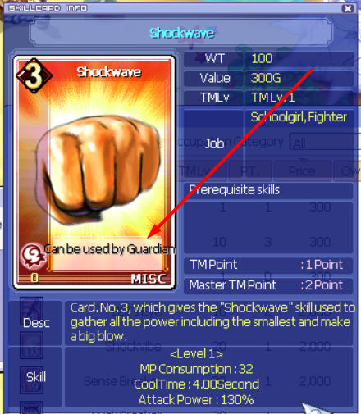

Q. How long will it take to do this?

1. Long answer: [spoiler]

Well, assuming you mean solely the Empathy portion, it depends on 3 things: prep, type, and method. The more you research and collect items beforehand, essentially, the quicker the process goes. As for the remainder, that's solely up to you. I don't like to level, so it took me an undetermined amount of time to finish. You can technically start this whole thing at level 65.

1. Short answer: My first guardian was a legendary and took me 10 days with minimal prep time and a lot of complaining to friends for cards. My second legendary I got in less than 3 days (you can only do so much Card ID, you know what I mean?)

Q: What is empathy?

1. Empathy is a “secret” point system that builds your guardian’s total build. You cannot see empathy at any time (although you can see the results of your labor after you do it a certain amount of times and level up the stat). The result is a build graph that looks very similar to the one in your MyView. I will explain more later.

Q. What is secret empathy?

1. That's a tricky one to explain in short. I will explain later.

Q. What is the best for me?

1. Depends on your play style. Do more research and you'll see what's your best fit. I do have a cookie-cutter build later in the guide for those who are interested in bossing.

Q. I want a legendary first!

1. OKAY NOT A QUESTION BUT I STRONGLY URGE YOU TO RECONSIDER. It's a super long and frustrating process and I would not wish my worst enemy to fail at the whole thing. I swore I screwed it up at the end because I didn't note the secret empathy and guessed. I essentially had an anxiety attack and turned it in anyway. Happy surprise. I am one of the few that didn't accidently screw it up. Don't risk it.

If I skipped a major question that can be explained in under a paragraph, please let me know. Otherwise, let’s begin!



# II. Card Identification Questline

Pre-requisites:

* Level 65+, 2nd job+
* One of each Arcana Card
* 5 Harkon Shards

TIP: Play the game normally from Blooming Cora to finishing Azteca. You should be level 66 at least at that point in normal servers, and can be up to 100 or higher in epTO

TIP: Card Girl’s riddles 1 and 2 in Southwest Forest and Gate of Azteca have 2 of the 4 Arcana cards

TIP: Ask around for the other two arcana cards. Other than this quest, they're basically worthless to players so they probably will be more than happy to give them to you.

TIP: The shards are found inside Harkon Heirlooms. These are drilled in Path to Mermaid 1&2 OR dropped by Cone Stones in the same area.

Method:

Essentially all you need is on this link here [[link]](https://wikimirror.lifeto.co/wiki.ggftw.com/trickster/Card_Identification_Quests_Guide.html). Brief description below.

Find the Poppouri in Poppouri Cave - Rainbow Cave. Anyone can essentially be teleported to the crawlspace, so don't let it fool you. Fairy Nono will essentially ask for each Arcana Card individually, where after you hand it in, you need to fight the monster that corresponds with each type. After the last “test”, you speak to Fairy Nono again, then speak to Artisan Poppuri in Moss Cave with the 5 harkon shards, then go BACK to Fairy Nono and get the Card Identification Skill.



# III. Soul Seed Questline

Pre-requisites:

* Level 135+, 3rd job
* Questionable Letter in Inventory
* CID questline finished (YOU DON’T NEED ALL SCS FOR THIS!!)
* Access to Mirage Island Field 6 (Finishing the Mirage Questline up to Mirage Island Field 4’s Sandmen quests [yes you have to complete the 4 sandmen’s quests])
* 10x Iron Knight’s, Brass Knight’s, Bone Fighter’s, Bone Warrior’s, and Bone Magician’s Souls
* 15x Cobra Flower, Tooth Flower, Mud Bigfoot, and Lotus Wormhole Seeds

TIP: You don’t have to give up your Dimensional Key if you don’t want to at the end. You can keep it and go to Eclipse’s dimension whenever you want. However, it cannot be stored in your bank, so be wary of that. You also won’t get the Dimensional Card Pack, which means you won’t get a free Secret Card.

TIP: Collect all the items beforehand.

TIP: You probably have some of the souls if you got 3rd job on your own without buying anything. If not or you don’t have enough, you can get the souls at various places in Vamp Castle.

TIP: All the Seeds are gotten in Swamp.

TIP: Make sure you collected your Questionable Letter from your System Mail.

Method:

Essentially, everything can be found here [[link]](https://wikimirror.lifeto.co/wiki.ggftw.com/trickster/Soul_Seed_Quests_Guide.html) step-by-step.

If you haven’t done Mirage when you were in Oops Warf your first time, it’ll definitely be easier to do so now. You can learn about the Mirage Questline here [[link]](https://wikimirror.lifeto.co/wiki.ggftw.com/trickster/Episode_3_Quests.html). However, you only need the sandmen’s quests completed to get through.



# IV. Soul Guardian Questline

Pre-requisites:

* Level 180+
* Third Job
* Matured Poseidon Seed
* Harkon
* Honey Tea
* All 16 SC cards for the Secret Space Map

Method:

The first thing you need to do is collect all 16 Secret Cards, and then check the “Secret” tab on your MyView. This allows you to go to Janus’s Secret Hideaway - Memory of Flames. Make sure to bring your Honey Tea and Harkon. You can easily make Honey Tea and can buy a Harkon generally in Mega player shops. Janus will ask you to kill a Red Flame Monster for him after you talk to him again. He’ll send you to Eclipse, where she will ask for an “Unknown item” which is your Honey Tea. Then, she sends you to Don Danihen who requires you to kill your Doppleganger which mirrors your level after talking to the Abraxas Mirror. Finishing that, just talk to Little Rosaline until she sends you back to Janus, who will give you your completed guardian.

TIP: If you plan on making any guardian requiring SEM, I *highly suggest* you CID for them instead of buying them, as you’ll eventually get each of them.

TIP: Harkon can be received by doing Blacksmith Marx’s questlines at Snow Hill and Tapasco Mines. You can also drill it up (rarely) in Techichi Fields, Tapasco Fields, Gate of Abyss, and Spicy Dragon’s boss room.

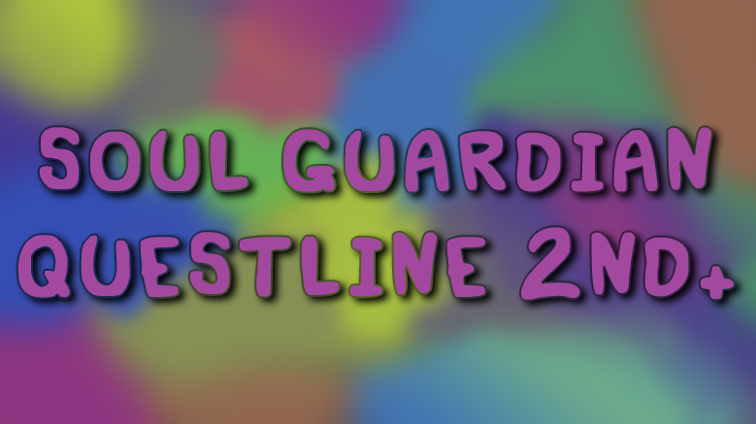

# V. Soul Guardian Questline 2nd+

Pre-requisites:

* One or more guardians
* Harkon (NOT in epTO!)
* Potentially a Soul Ticket, if this is beyond your 2nd.
* Space Map
* Poseidon OR Spinel Seed (doesn’t matter if mature or not)

Method:

Literally just use the Space Map after getting your new guardian seed to whatever build you like, talk to Janus, give him the Harkon, and you’re done. It’s that easy. Check if you need a Soul Ticket beforehand. You get 2 free guardian slots (courtesy of Janus), but after that, you need a Soul Ticket for every guardian you want.

NOTE: In epTO, you get a Spinel seed for free at the end of Episode 6!



# VI. Card Identification

Pre-requisites:

* CID skill
* Monster and Character Cards
* Some ability to mix and match

TIP: General questing gives character cards.

TIP: If you start a character from scratch and get it through all the way to Azteca (totally do-able in a day), you will have ample cards to get started, character and monster alike.

TIP: People will generally sell cards for 15,000 galder. 15k is the universal price. Up to 300k means they’re usually for a skill mastery. Do not let people rip you off.

TIP: If you are doing a legendary guardian, do NOT start this process before you get your soul seed. Trust me. You’re better off.

## About CID:

Card Identification is the natural method to getting Secret Cards and secret empathy points for your soul seed. You can also get other goodies such as compound stones, potions, and chaos feathers, all scaled based on the level you get to.

Diagram of CID:

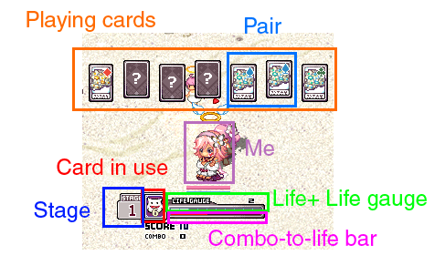

Stage - How many cards this playthrough you’ve used without losing all your lives

Life - How many times you can fail before it boots you from this minigame

Life bar - Diagram of the lives you have comparatively

Playing Cards - As all boardgames, this is where you play

Card in use- This is the card you used this round

Combo - How many pairs in a row you’ve discovered. You can get extra lives with better combos

Symbol (see: Top-right of revealed cards) - These are based on suites you’d find in a normal card-game along with 4 colours each. These are how you know what to pair with if you don’t want to hover over the board all the time

Pair - Same-symboled, same-imaged cards. Your goal.

### BEFORE YOU CID - CARD INFO:

This part of the guide is something you must, must, must know before you even start. Many people are unaware of how the process works or how cards influence their minigameplay. This is where you will know more than many people already with a guardian do.

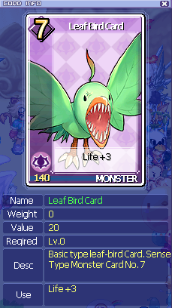

This is a diagram of a simple card when you right click on one or press “view” in the card inventory menu. Notice anything on the card or under a specific tab that may be of use to us? When you right click, you can tell which cards are going to give a certain amount of Life to our CID process at the beginning. Use the higher-numbered cards for the first stage *only*. This will help for when you make mistakes. From the second stage-on, you should use +3 Life cards. Many people wonder why they can’t get to higher stages but THIS IS MAINLY WHY!! It isn’t a lack of skill, it’s the lack of resource utilization. Make sure to check how much life your cards give before using them. Also, if you make combos, you can gain lives easily. Be aware of that.

NOTE: THERE WILL BE ONE OUTLIER CARD!! THIS ONE CANNOT BE MATCHED. Match the other ones in order to reveal this one!

## CID - Q&A

Q. How many cards will I need?

1. The answer is simple: No one knows. You will need an upwards of 1,000, guaranteed. After that is up to how you CID/if you do anything fortune-related/anything else SEM-related. The only difference is Spinel where you need about double anything

Q. Do I need to CID/get secret empathy?

1. The only ones that need SEM are Legendary and Accomplished. Neither of these do anything but change appearance, have a different title, and can hold a certain amount of skills more/less than others. It also gives you some credit towards patience, but if you’re not in it for looks, not really necessary. Accomplished looks like Mighty guardians since they share the same sprite and Legendary is its own visual. Based on that is how you want to go about it. If you don’t want a Legendary or Accomplished, congrats. You don’t need SEM!! Pat yourself on the back because you just skipped something very time-consuming and money-capturing.

Q. Should I do CID first or after setting up my EM?

1. You should CID first. This will affect how you set up your EM completely, and if you’re going for an Accomplished guardian, make-or-break your guardian plans in general since that relies on that +2 as the final.

## HOW REGULAR EMPATHY WORKS

There’s 4 types of regular empathy: Power, Charm, Magic, and Sense. Each of these numbers on this diagram here are said types which correlate with the 4 different types of characters in the game.

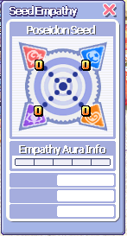 your new best friend

You gain empathy by doing several things. This table (scroll down, sorry :( ) will tell you most of what is known regarding gaining empathy.

### Regular Empathy Guide: (scroll down)

Note: “level” in this chart means “level cap” so the max level it applies to the guardian.

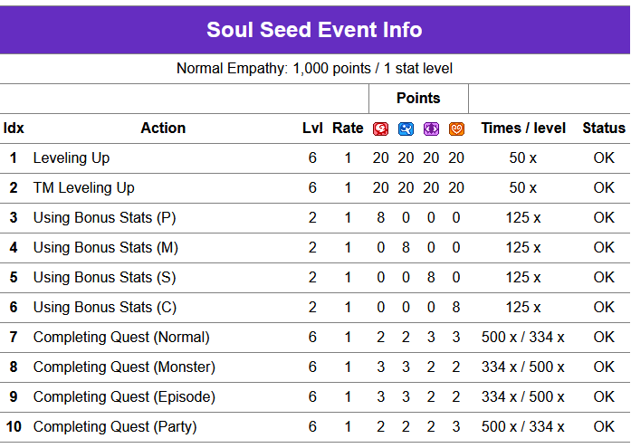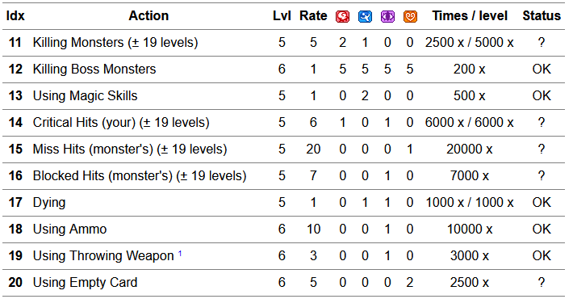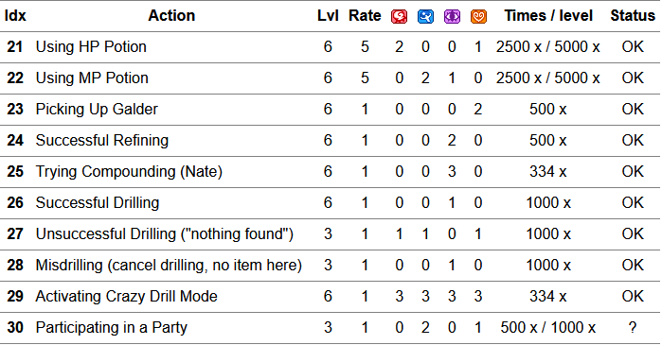

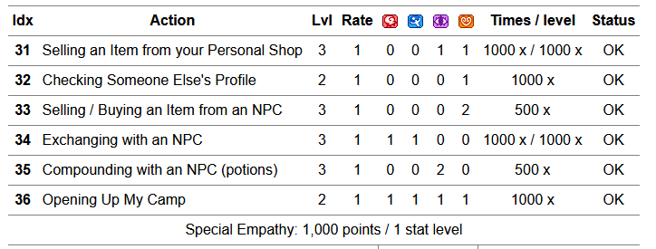

## HOW SECRET EMPATHY WORKS

You gain secret empathy by using a card for CID, getting past stage 3 in CID, matching 2 SC tiles to gain a SC in CID, and any fortune read from Stella. The numbers were released a little while ago, and are attached if you scroll down a bit more. I’m just going to tell you this expedites the process by doing any of these and the more you do the later 3 things, the less cards you are going to need. This is why no one gives a straight number. Because there is no straight number. It’s all on you. The number could be 1500-1800, but with Spinel, this number doubles–expect at least 3500 cards with her.

What SEM is going to do to your seed is give it +1 for each type except one, which will be +2. This, to the extent of my knowledge, is pure RNG. You won’t be able to see the empathy until after it hatches, which is where the “Secret” comes from. It’s up to you to mark that last 3 flashes caused by CID/fortune-telling. But, you must, must, must finish with CID and not Fortune-Telling. If it no longer glows at Fortune-telling, CID until it stops flashing from doing so.

TIP: Hate matching games? Mill it. This is where you start CID, select a card, right click, exit, and repeat. I like to do this near the end because I have grown to hate CID. I actually add that I click on four cards, just to check to see if there’s any SCs there (you would be surprised what I’ve gotten on stage 1).

Scroll down for a SEM guide!

Note: “level” in this chart means “level cap” so the max level it applies to the guardian.

### **SEM Guide:**

NOTE towards fortunes:

only stat bonus -> 0 gives special empathy points

if a stat is raised by +0 -> no special empathy points

Joker and DX fortune bonus-> no special empathy points



# VII. Universal Guardian Information

1. All builds start out at 0,0,0,0.
2. Any builds that end up at 0 at the end will be turned into 1 automatically after hatching.
3. All stats cause the seed to mature, or be unable to adjust the build, at 6 points of regular empathy, so plan accordingly.
4. Type of guardian is determined by the highest number in the build. If it’s two of the same, the one that has more experience put into it will be the resulting type.

Ex.. If you did 10 shimmers more than “4” on charm and did only up to “4” in power, it’ll end up a charm type.

1. All guardians can learn skills after hatching, but only ones with the green bookmark at the top-left.

Ex. 

1. You can name/rename your guardian with a Soul Feather Pen, found in MyShop> Pet&Drill> Guardian.

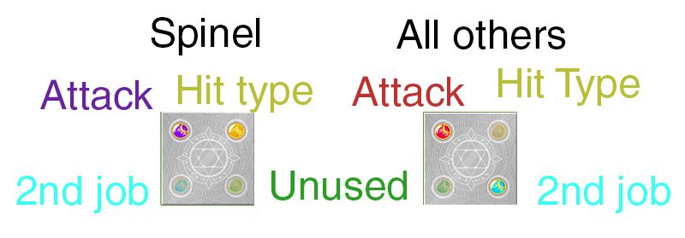

1. All guardians (except Spinels) start out with a single-target attack. You can buy yellow runes to change to either multi-targeting or auto-targeting in MyShop> Pet&Drill> RuneStone. (runes pictured above)
2. Guardians cannot learn 2nd job skills without the corresponding Blue Rune. Buy them at MyShop> Pet&Drill> RuneStone. There’s one for each 2nd job type.
3. Blue Rune types allow for both characters of said type’s skills (i.e. Cochma’s Rune allows both Lion and Fox 2nd job skills), so you don’t need two runes for the same type.
4. You can only have one rune per slot, so if you want to change runes, the one equipped will be destroyed and replaced with the new rune.
5. After your second guardian, you must purchase a Soul Ticket for another guardian slot. You can purchase this at MyShop> Pet&Drill> Guardian.
6. You can’t replace the Top-left rune or add one to the Green slot. Original Trickster Online development never got that far.
7. Spinels are naturally the hardest to obtain.
8. Spinel seed+Secret Map package is sold under MyShop> Pet&Drill> Guardian, as well as regular Poseidon Seeds and Secret Maps. NOTE: IF YOU BUY THE SPINEL PACKAGE, YOU WILL GET THE SEED AND THE MAP. YOU DO NOT NEED TO BUY ANOTHER!!!!

## Guardian Types and Looks

Now, guardians from easiest to hardest...

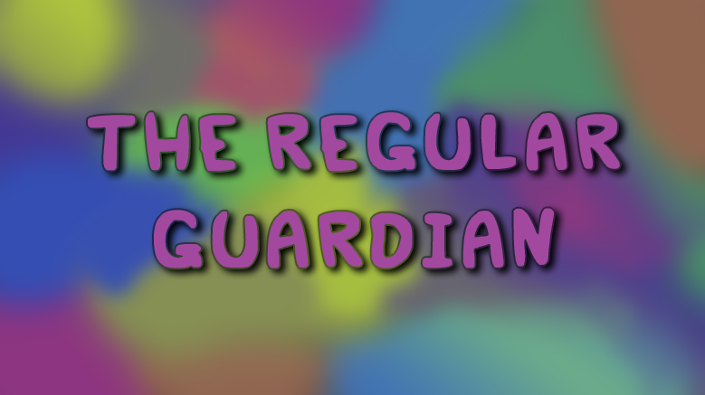

# VIII. The Regular Guardian

Literally any guardian that isn’t Mighty, Accomplished, Superior, or Legendary.

4~12 points.

Cannot be 3,3,3,3!!! This creates a superior build.

TIP: If you’re just doing your first guardian to get to Spinel, if you have all your SCs, you can just hatch it immediately with a 0,0,0,0 build. It will end up a 1,1,1,1 after hatching and you can start on your Spinel right away!

You can check out builds here: [Basic Guardian Builds](https://docs.google.com/spreadsheets/d/1SkdhgabTyefBNrZ_WfSMQdHrddwXcTSJDchQWQl--GU/edit#gid=0)

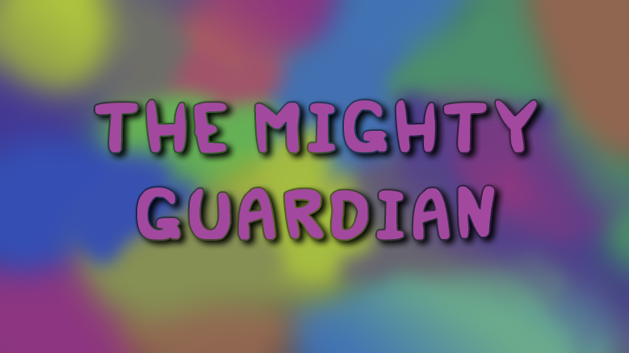

# IX. The Mighty Guardian

Builds at 13~15 points. Easiest is 14 points. If you decide to max one of your guardians’ stats, do this last. Otherwise you’ll end up with less than desirable. It’s just inefficient. This is also the best starting build for a bossing guardian, which I will explain later.

You can check out builds here: [Basic Guardian Builds](https://docs.google.com/spreadsheets/d/1SkdhgabTyefBNrZ_WfSMQdHrddwXcTSJDchQWQl--GU/edit#gid=0)

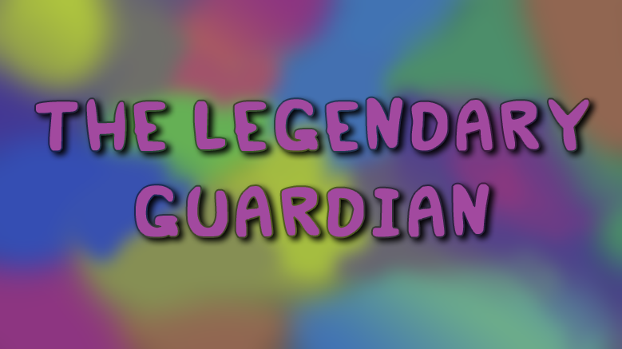

# X. The Legendary Guardian

18~19 points. Requires CID.

Yes, the alleged “hardest” build. It’s probably the longest, yes, but it is NOT the hardest. Most people feel it’s hard because it’s tedious, but it is definitely middle-of-the-road.

CID until it stops flashing when you use cards. Throw in some Fortune-telling to speed up the process. CID is the only thing necessary.

PLEASE for the love of all things beautiful and hat-filled, read this section [link to IV]. Please. Please. I hate repeating myself and I abhor inefficiency.

You can view builds here: [Basic Guardian Builds](https://docs.google.com/spreadsheets/d/1SkdhgabTyefBNrZ_WfSMQdHrddwXcTSJDchQWQl--GU/edit#gid=0)

## REMINDERS:

-THE SEM IS RANDOM. YOU CANNOT PREDICT THIS. PAY ATTENTION TO THE FLASHES!!!!!!!

- PLEASE, PLEASE, PLEASE PAY ATTENTION TO THE LIFE OF YOUR CARDS!!! YOU COULD BE WASTING YOUR HARD-EARNED/SPENT CARDS!!!

- YOU CANNOT SEE SEM POINTS UNTIL AFTER YOU HATCH SO PAY ATTENTION TO THE FLASHES!!!!

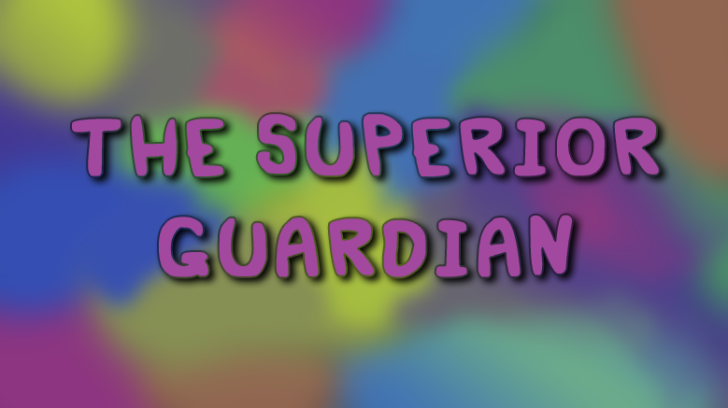

# XI. The Superior Guardian

Requires either 12 (3,3,3,3) OR 16 (4,4,4,4) AFTER hatch. Unlike Legendary and regular, you can’t be reckless. Mirrors Mighty’s need for specific numbers.

How to make sure you get the guardian you want:

1. Plan, plan, plan!
2. Pay attention when you do everything. Keep your build up at all times and watch what affects it and what doesn’t.
3. Do NOT do your desired stat last. And do NOT stop your desired stat the second it goes to 3 or 4 (whichever build you are looking at). I like to do it first, but only because that’s the one I pay attention to the least and allow it to keep going a bit longer than needed.
4. Your desired stat must, must, must be the one with the most “extra” put into it without exceeding 3 or 4 points (depending on your build). A lot of guides get this wrong and tell you to do your desired stat last, but that makes it much, much harder to remotely get the one you want. It’s how people who are going for a power superior get a charm and vice versa.

You can view builds here: [Basic Guardian Builds](https://docs.google.com/spreadsheets/d/1SkdhgabTyefBNrZ_WfSMQdHrddwXcTSJDchQWQl--GU/edit#gid=0)

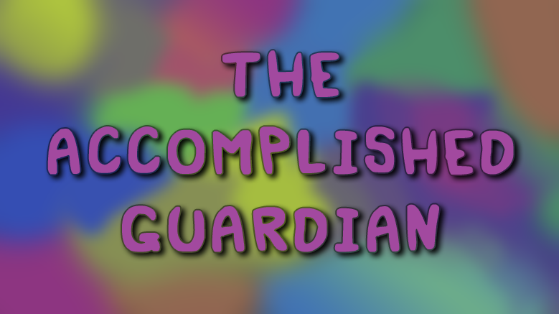

# XII. The Accomplished Guardian

Only allows for 16 point builds. Everything must be 4,4,4,4 *AFTER* hatching *AND* CID!!!!!!!!! REQUIRES CID. Literally the hardest to do. The love child of Legendary and Superior Guardians.

You thought Legendary was hard? Try one you can actually truly fail at.

Do your SEM process first. For the love of hats, please pay attention to the flashes. You can NOT do this build without that knowledge. When you’re finished SEM, start with EM. You need to make it 3 across the board except for the SEM’s +2 (THIS IS WHERE YOU PAID ATTENTION TO THE FLASHES, RIGHT????????).

You can view builds here: [Basic Guardian Builds](https://docs.google.com/spreadsheets/d/1SkdhgabTyefBNrZ_WfSMQdHrddwXcTSJDchQWQl--GU/edit#gid=0) (in progress!)

## NOTE: IF YOUR SEM’S +2 LANDS ON YOUR DESIRED TYPE, YOU CAN NOT, I REPEAT, CANNOT GET THAT GUARDIAN.

# XIII. The Cookie Cutter Build (Mighty/Legendary)

Other builds found here: [Basic Guardian Builds](https://docs.google.com/spreadsheets/d/1SkdhgabTyefBNrZ_WfSMQdHrddwXcTSJDchQWQl--GU/edit?usp=sharing)

This works for most characters, but you may want to adjust one or two stats, depending on your character type. It is the most optimal for boss-hunting, especially soloing Koi, which is the intention for this guardian. This will be a Legendary/Mighty Ifron with the Poseidon/default seed, depending on whether or not you do the full SEM or not.

The best build for this is 3263, or 3 power, 2 magic, 6 sense, 3 charm.

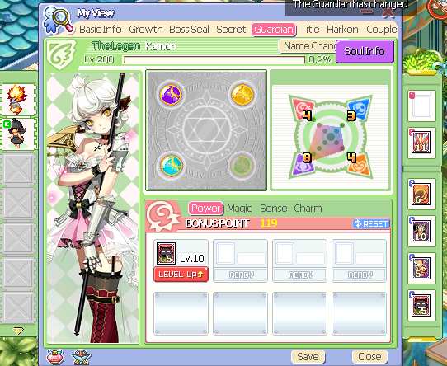(+2 Sense legendary with cookie-cutter build)

## The way to build this:

View character profiles (preferably a private one, via spam-click): 2 charm

Consume 7.5k hp pots: 3 power, 3 charm

Consume 5k MP pots: 3 power, 2 magic, 1 sense, 3 charm

Drill (spam-click a squiggle tile* until level 3, then drill WITH items until 6): 3 power, 2 magic, 6 sense, 3 charm

*

Condensed build (not recommended; can’t learn mana arrow+arrow rush for penguins or cure and skunk pouch is more likely to fail; also, potential to fail the build is higher due to the “nothing found” bug, but you are welcome to try; **DO NOT USE IF YOU ARE A MAGIC TYPE**):

7.5k HP potions: 3 power, 1 charm

2.5k MP potions: 3 power, 1 magic, 1 charm

AFK drill: 3 power, 1 magic, 6 sense, 1 charm

## Skills to know:

Power: Shockvibe and Luck Breaker OR Faint, Armor Breaker, Shockwave

Magic: Cure

Sense: Stone Strike (lv 10); Armor Destroyer (1); Lucky Seven (10); Shield Breaker (10); Lucky Fist (10)

Charm: Skunk Pouch

**SCROLL DOWN DO NOT STOP HERE**

### **WARNING**: If you wear a Louis’s rune to equip Faint+Guardbreak, it will still apply to shockwave after you equip Cochma to get Shieldbreaker+Lucky Fist (this bug only applies to passive skills, not active ones, for those that are interested in building)

**Disclaimer**: If you are a **mage**, do **NOT** use Louis’s rune and instead opt for Luck Breaker (Power) and Magic Defense Break (Charm).

**Disclaimer**: If you are a **Sense** type using long-ranged (throwing, guns), use Skunk Pouch / Lucky fist / Luck Break / Shield Break on repeatable slots and Sticky Foot on singular slots. If you did sense to 6, you should be able to do this just fine. If not, just ignore Sticky Foot.

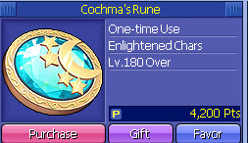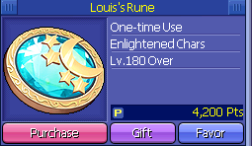

Skill Order to use



# XIV. CREDITS

Almora’s guide, which I got a hefty amount of information from thanks to how detailed it was. Thank you for my lead into my first guardian. Check it out here <http://web.archive.org/web/20161028052334/http://ggftw.com/forum/trickster-online-general-guides/106759-general-guardian-faq.html#post1661047>

Geepie, for another great guide http://board.playtrickster.com/index.php?/topic/11082-guardians/

Infinity, the guild, for first helping me with my first ever guardian on rTO.

BeProud and JjaeQT, for helping give advice regarding builds.

Bunny, for good ideas for other hints and helpful tips to add to the guide.

All my friends that had no idea what to do about their guardians to the point where it became essential to create this guide.

The admin and mods for continuing to try your hardest to making this place worthwhile.

All my hats that inspire me to keep playing.

All images and content do not belong to me. I am in no way doing this for any reason but educational purposes. Thank you for reading.